RV COLLEGE OF ENGINEERING ®
BENGALURU-560059
(Autonomous Institution Affiliated to VTU, Belagavi)



“Agricultural Chatbot”
Assignment Report
Database Management Systems & Web Programming
(16IS64/16IS62)
Submitted By
Kiran Ravi Hegde (1RV17IS015) R O Sugam Kumar (1RV17IS029)
Rohit M (1RV17IS032) Saksham Garg (1RV17IS035)

Under the Guidance of
Dr.Padmashree T Prof. Rashmi R
Assistant Professor Assistant Professor

in partial fulfillment for the award of degree of
Bachelor of Engineering

in
INFORMATION SCIENCE AND ENGINEERING
Jan-May 2020
CONTENTS

- INTRODUCTION
- PROBLEM STATEMENT
- DBMS COURSE CONCEPTS
  - ER DIAGRAM OR SCHEMA
  - TECHNOLOGIES USED
- WEB PROGRAMMING COURSE CONCEPTS
  - TECHNOLOGIES USED
  - CONCEPTS USED
- ASSIGNMENT OUTCOME
  - DBMS LEARNING BEYOND THE SYLLABUS
  - WEB PROGRAMMING LEARNING BEYOND THE SYLLABUS
- CONCLUSION
  - OUTCOME OF THE PROJECT
  - FUTURE ENHANCEMENTS

INTRODUCTION

Agriculture plays a vital role in the Indian economy. It is the only means of living for almost two-thirds of the employed class in India. Proper information about agricultural practices is the key to optimal agricultural growth and output. In order to answer the queries of the farmer, we have build an agricultural chatbot based on our own dataset. This system is available anytime and can be accessed through any smartphone and the information is delivered with the ease of understanding. With this system, farmers can progress towards easier information about farming related practices and hence a better agricultural output.

PROBLEM STATEMENT

With this project we aim to provide an easy solution for farmers, so as to provide them with the best solutions. Usually farmers can contact the farmer helpline for clearing theses queries, however these hot lines are not always available, however a chatbot capable of answering the same questions is an ideal solution.

We aim to create a chatbot which can answer some common agro-related queries any person might have.

DBMS COURSE CONCEPTS

a. Schema

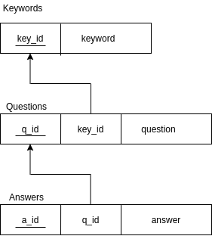

b. Technologies Used

In this project we have made the entire website in JavaScript because of its high flexibility, versatility and ease of use. Quite a lot of frameworks are available for designing a website in JS, we have made use of a MERN stack which stands for -
M-MySQL
E-Express
R-React
N-Node

We have used the below listed technologies for our backend:
- MySQL
- Node.js
- Express

MySQL is a relational database management system (RDBMS) based on structured query language (SQL). We have used it for the purpose of a web database.

Node.js is a packaged compilation of Google’s V8 JavaScript engine, the libuv platform abstraction layer, and a core library, which is itself primarily written in JavaScript.

Node.js shines in real-time web applications employing push technology over web sockets.
It’s speed, concurrency and event based model made us lean towards using node

Express.js is a Node js web application server framework, which is specifically designed for building single-page, multi-page, and hybrid web applications. Express is generally used with node, because it makes routing and REST API much easier than when compared to plain Node.

Important Features and Concepts Used

REST determines how the API looks like. It stands for “Representational State Transfer”. It is a set of rules that developers follow when they create their API. One of these rules states that you should be able to get a piece of data (called a resource) when you link to a specific URL. Each URL is called a request while the data sent back to you is called a response. The REST API supports cross-origin resource sharing (CORS) security.

CORS stands for Cross-Origin Resource Sharing. Normally, requesting resources across domains is a security risk. If a random site could pull data into JavaScript from another, the random site could "steal" information that way. If the target site were, say, your bank's website, perhaps just visiting such a site could get sensitive information leaked. For this reason, modern browsers will ask the target site for CORS HTTP headers that list the requesting site as allowed to request resources cross-origin from it. If the target site doesn't return such headers, then the request is denied at the browser level. This lets "good" requests through that the target site allows, but leaves "bad" requests that aren't whitelisted, blocked.

WEB PROGRAMMING COURSE CONCEPTS

a. Technologies used

We have used the below listed technologies for our frontend:
- React JS

React.js is an open-source JavaScript library that is used for building user interfaces specifically for single-page applications. It’s used for handling the view layer for web and mobile apps. React also allows us to create reusable UI components. React allows developers to create large web applications that can change data, without reloading the page. The main purpose of React is to be fast, scalable, and simple. It works only on user interfaces in the application.

Important Features and Concepts Used

In React, instead of using regular JavaScript for templating, it uses JSX. JSX is a simple JavaScript that allows HTML quoting and uses these HTML tag syntax to render sub components. HTML syntax is processed into JavaScript calls of React Framework. We can also write in pure old JavaScript.

In React, a set of immutable values are passed to the components renderer as properties in its HTML tags. The component cannot directly modify any properties but can pass a call back function with the help of which we can do modifications. This complete process is known as “properties flow down; actions flow up” and is referred to as Single way data flow

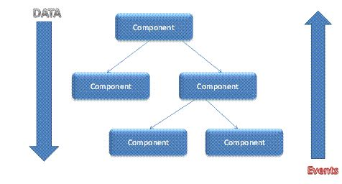

Virtual Document Object Model

React creates an in-memory data structure cache which computes the changes made and then updates the browser. This allows a special feature that enables the programmer to code as if the whole page is rendered on each change whereas react library only renders components that actually change.

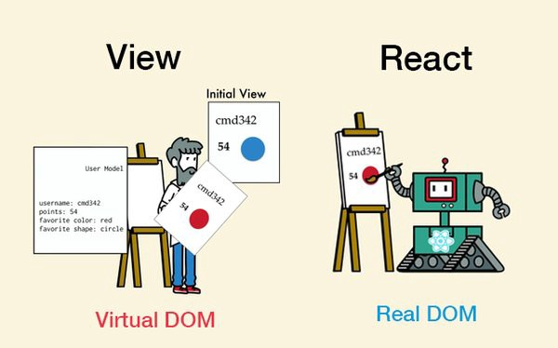

CONCLUSION

a. Outcome of the project
In this project, we created a chatbot, where user can ask a question, this question is split into individual words and we map these words to existing keywords from our keyword table in the database. The database returns the list of keyword ids which exsist, then a combination of these keywords is looked from in the question table, if the question table is able to locate an equivalent set of keywords, then the corresponding answer is returned to the frontend, if a match is not occurred we return a default sentence.

Since there is no machine learning involved, the functioning of the chatbot is highly dependent on the amount of data in the database, however if we include NLP we can make this into a much more efficient service.

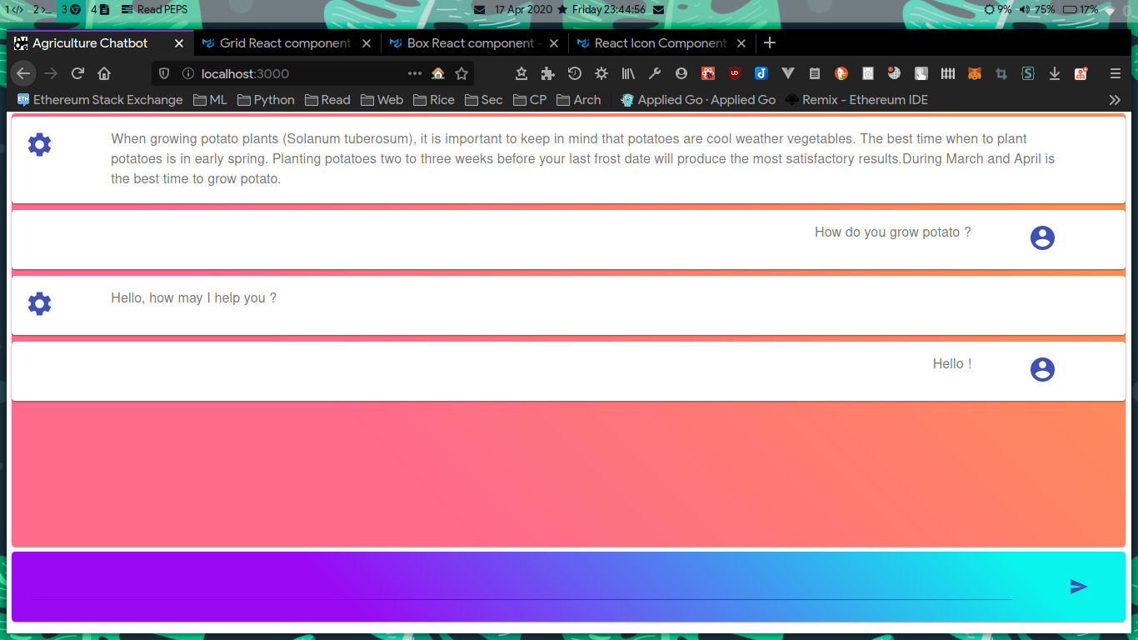
Screenshot:

b. Future Enhancements

In the future our chatbot can be enhanced by powering it with artificial intelligence (AI).
By using various machine learning algorithms, we can further enhance the context and accuracy of the results.

